Incident Statistics Reporting Module
A Quick Guide

1. Incident Statistics Reports

These reports will display the data related to the Incident Statistics.
To Navigate to this module login into BI instance using the below url.
http://192.168.166.203:9704/analytics/saw.dll?bieehome&startPage=1

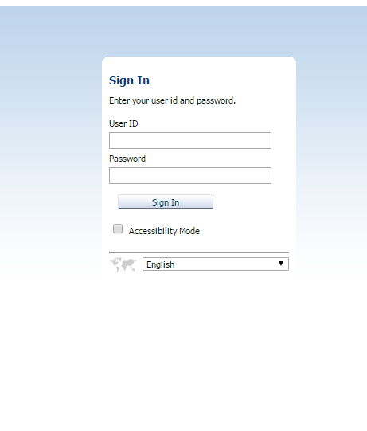

Enter the below Credentials
User ID : Operations
Password : Welcome1

Once Logged in then navigate to the dashboards and select Port calls Dashboard

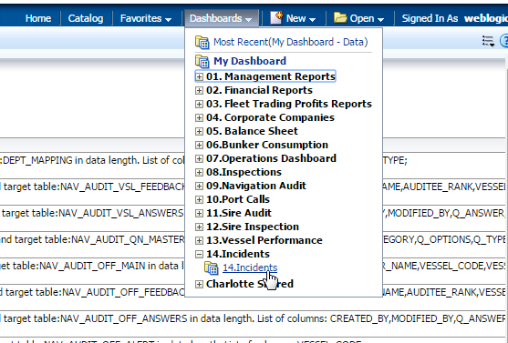

Select the Incidents dashboard to view the Reports related to incident management.

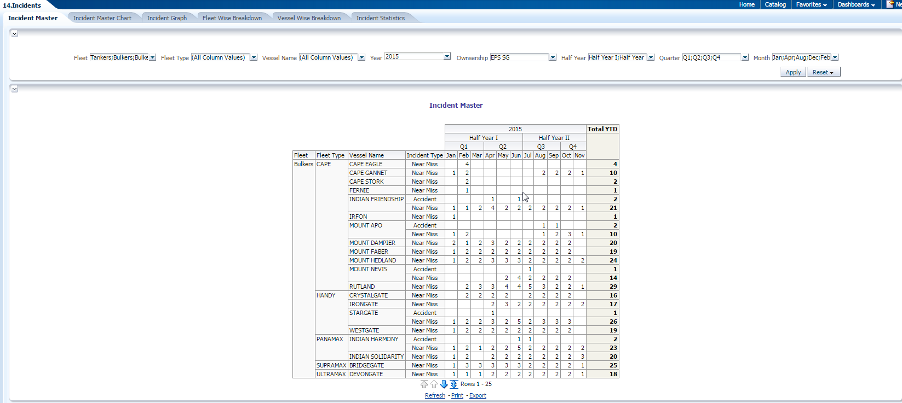

- There are 6 dashboards for the incident dashboards.
    - Incident Master : This is the master report about the details of the “Near Miss” and “Accident” in a pivot table across “Month”,”Qtr”,”Half Year”,”Year” for Fleet and vessel.
    - Incident Master chart: This dashboard gives the number of “Accident” and “Near Miss” in a PIE chart for FLEET A,FLEET B,FLEET C. FLEET is drillable to the vessel.
    - Incident Graph : This dashboard gives the count of Incidents of type “Near Miss” and “Accident” for the Fleet.
    - Fleet wise break down: This dashboard gives the break down of the Incident Types “Near Miss” and “Accident” across the fleet by “Quarters”
    - Vessel wise break down: This dashboard gives the break down of the Incident Types “Near Miss” and “Accident” across the vessel by “Quarters”
    - Incident Statistics : This dashboard gives the count of incidents for the primary categories for the fleet and vessel.

Parameters for the Incident Master Dashboard:
- Fleet : Type of fleet (i.e., Tankers ,chemical etc)
- Fleet type : Fleet sub type like AFRAMAX etc
- Vessel : Vessel Name
- Year : Year for which the data to be displayed
- Owner ship : Ownership type as EPS-SG or EPS-UK
- Half Year : Either Half Year 1 or Half Year 2
- Quarter: Q1,Q2,Q3,Q4
- Individual Month : Month for which the data to be displayed

Parameters for the All the remaining dashboards:
- Fleet : Type of fleet (FLEET A,FLEET B,FLEET C)
- Year : Year for which the data to be displayed
- Owner ship : Ownership type as EPS-SG or EPS-UK
- Half Year : Either Half Year 1 or Half Year 2
- Quarter: Q1,Q2,Q3,Q4
- Individual Month : Month for which the data to be displayed

- Incident Master Dashboard

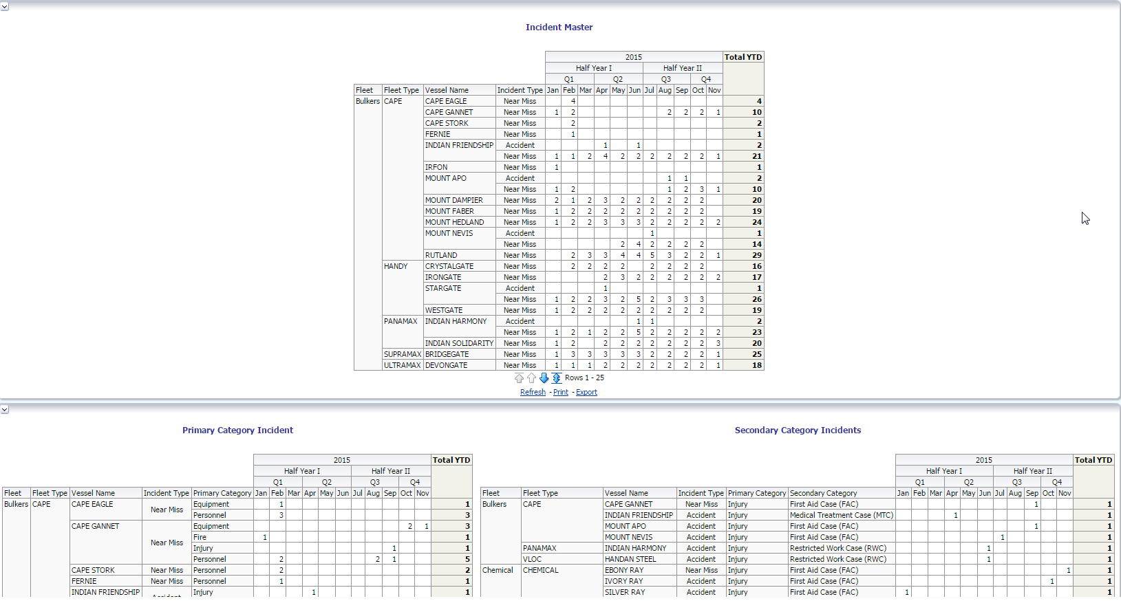

- Incident Master Chart:

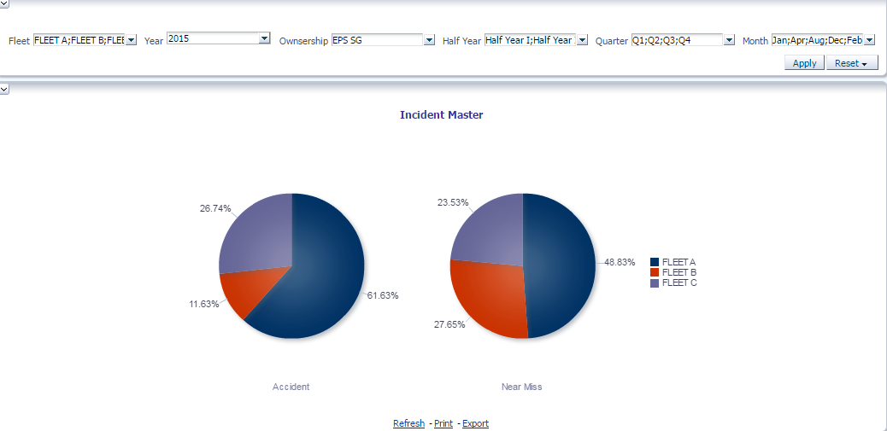

This chart is drillable and user can drill to the vessel level from Fleet
- Incident Graph:

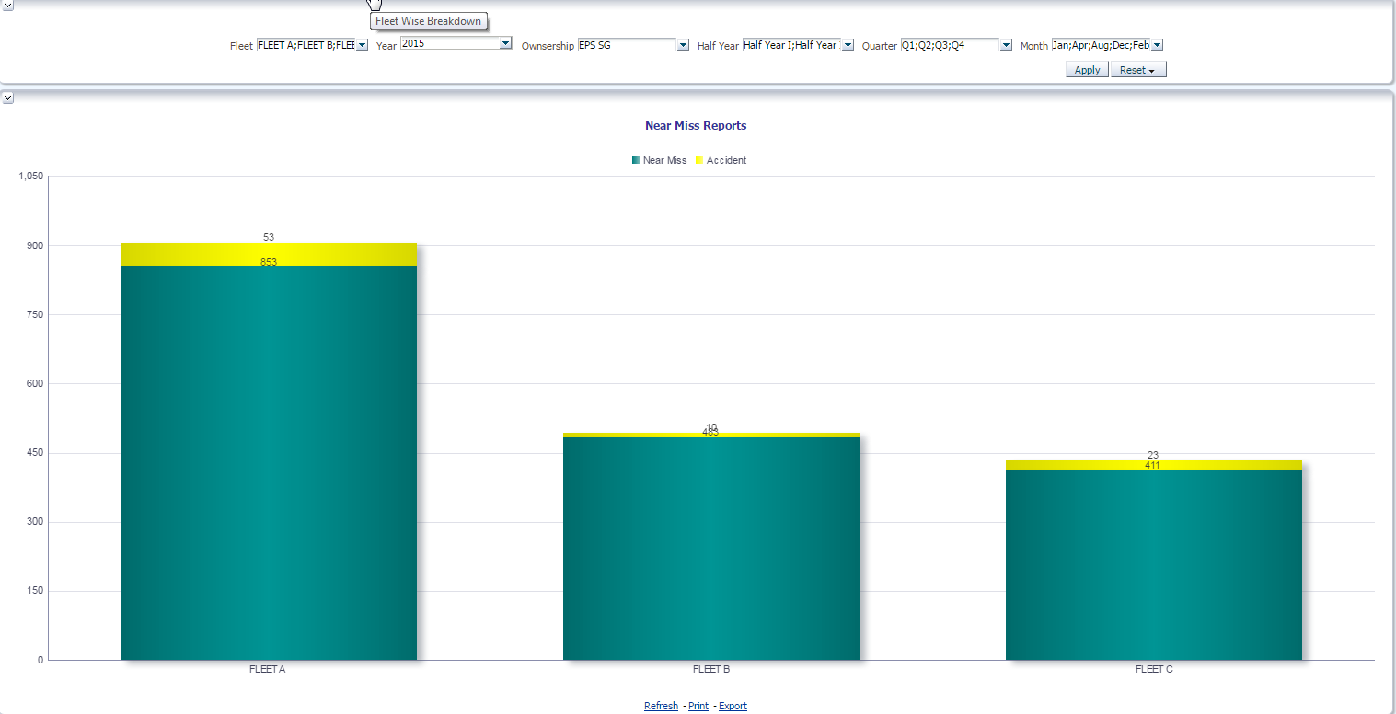
This chart is drillable and user can drill to the vessel level from Fleet
- Fleet Wise Breakdown:
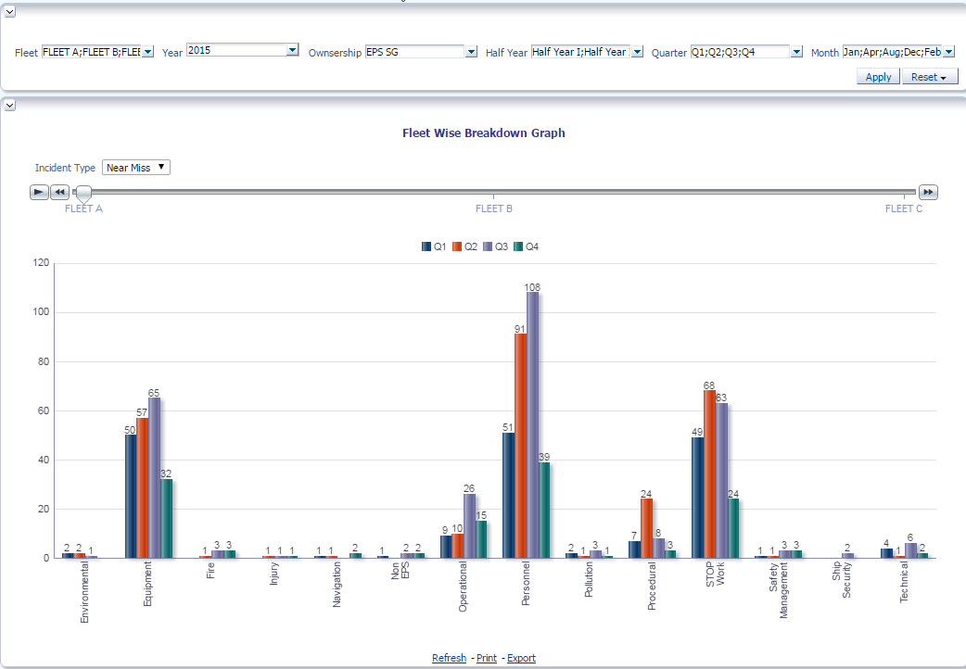

This is not drillable graph
- Vessel Wise Breakdown:
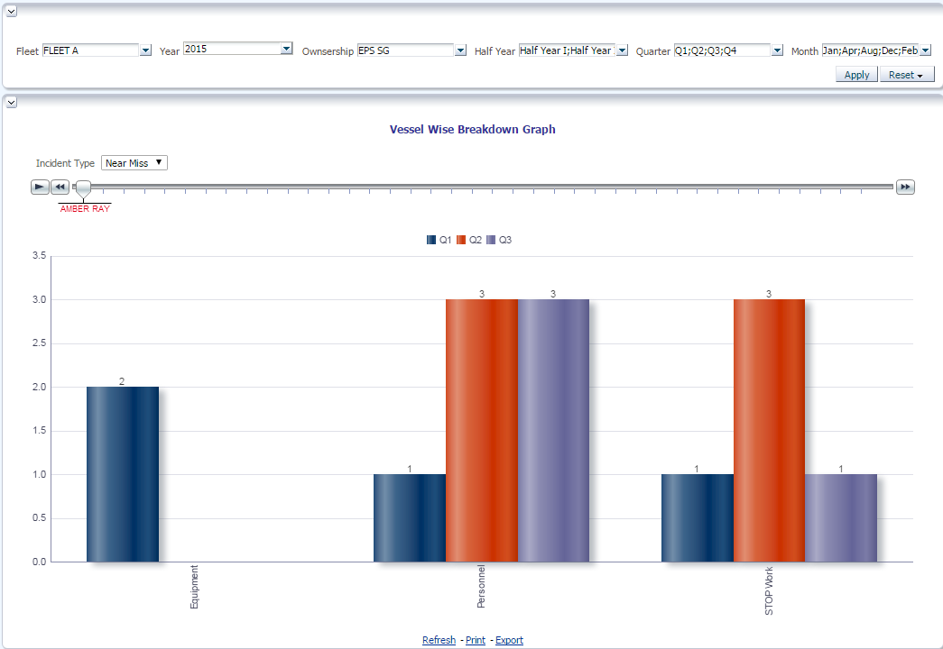
This is not drillable graph
- Incident Statistics :
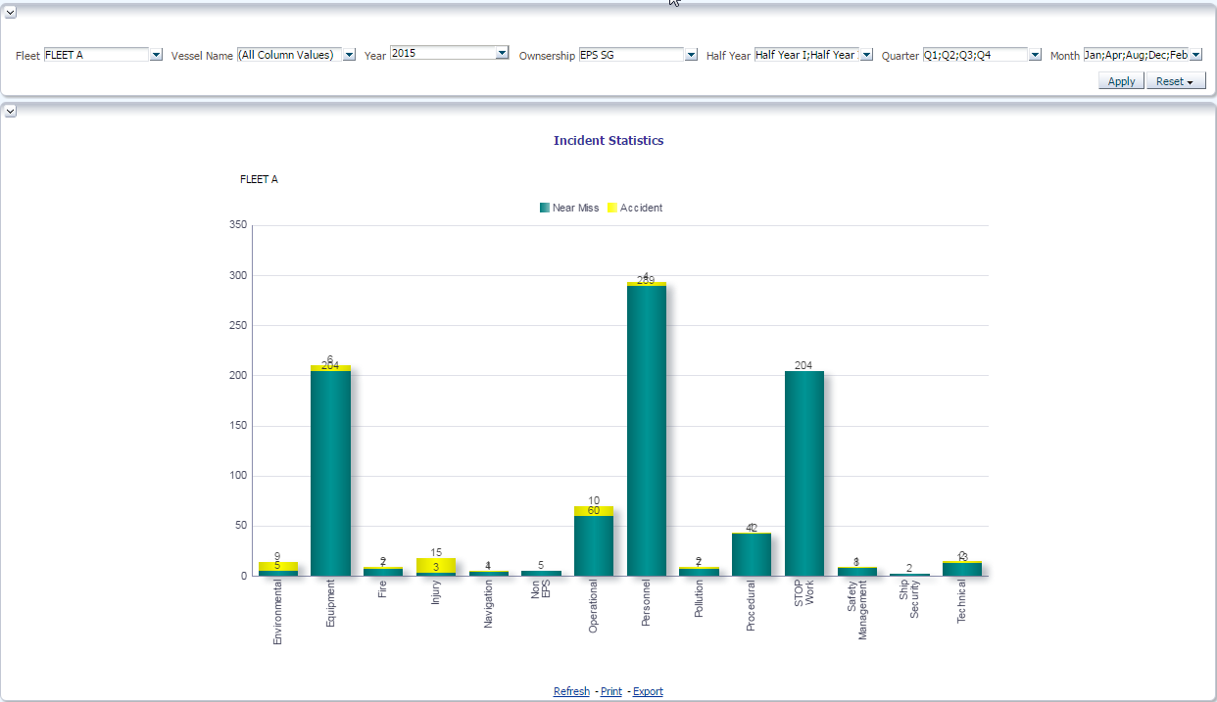
This is not drillable graph

